**WEEK 3**

**SPRING-DATA-JPA-HANDSON**

**EXERCISE 1: CONFIGURING A BASIC SPRING APPLICATION**

**CountryService.java**

package com.cognizant.ormlearn.service;

import java.util.List;

import org.springframework.beans.factory.annotation.Autowired;

import org.springframework.stereotype.Service;

import org.springframework.transaction.annotation.Transactional;

import com.cognizant.ormlearn.model.Country;

import com.cognizant.ormlearn.repository.CountryRepository;

@Service

public class CountryService {

@Autowired

private CountryRepository countryRepository;

@Transactional

public List<Country> getAllCountries() {

return countryRepository.findAll();

}

}

**CountryRepository.java**

package com.cognizant.ormlearn.repository;

import org.springframework.data.jpa.repository.JpaRepository;

import org.springframework.stereotype.Repository;

import com.cognizant.ormlearn.model.Country;

@Repository

public interface CountryRepository extends JpaRepository<Country, String>

{

}

**Country.java**

package com.cognizant.ormlearn.model;

import jakarta.persistence.Column;

import jakarta.persistence.Entity;

import jakarta.persistence.Id;

import jakarta.persistence.Table;

@Entity

@Table(name = "country")

public class Country {

@Id

@Column(name = "co_code")

private String code;

@Column(name = "co_name")

private String name;

// Getters and Setters

public String getCode() {

return code;

}

public void setCode(String code) {

this.code = code;

}

public String getName() {

return name;

}

public void setName(String name) {

this.name = name;

}

// toString

@Override

public String toString() {

return "Country [code=" + code + ", name=" + name + "]";

}

}

**OrmLearnApplication.java**

**package** com.cognizant.ormlearn;

**import** java.util.List;

**import** org.slf4j.Logger;

**import** org.slf4j.LoggerFactory;

**import** org.springframework.boot.SpringApplication;

**import** org.springframework.boot.autoconfigure.SpringBootApplication;

**import** org.springframework.context.ApplicationContext;

**import** com.cognizant.ormlearn.model.Country;

**import** com.cognizant.ormlearn.service.CountryService;

**import** org.slf4j.Logger;

**import** org.slf4j.LoggerFactory;

**import** org.springframework.boot.SpringApplication;

**import** org.springframework.boot.autoconfigure.SpringBootApplication;

@SpringBootApplication(scanBasePackages = "com.cognizant.ormlearn")

**public** **class** OrmLearnApplication {

**private** **static** **final** Logger ***LOGGER*** = LoggerFactory.*getLogger*(OrmLearnApplication.**class**);

**private** **static** CountryService *countryService*;

**public** **static** **void** main(String[] args) {

ApplicationContext context = SpringApplication.*run*(OrmLearnApplication.**class**, args);

***LOGGER***.info("Inside main");

*countryService* = context.getBean(CountryService.**class**);

*testGetAllCountries*();

}

**private** **static** **void** testGetAllCountries() {

***LOGGER***.info("Start");

System.***out***.println("Start fetching countries");

**var** countries = *countryService*.getAllCountries();

***LOGGER***.debug("countries={}", countries);

***LOGGER***.info("End");

}

}

**OUTPUT**

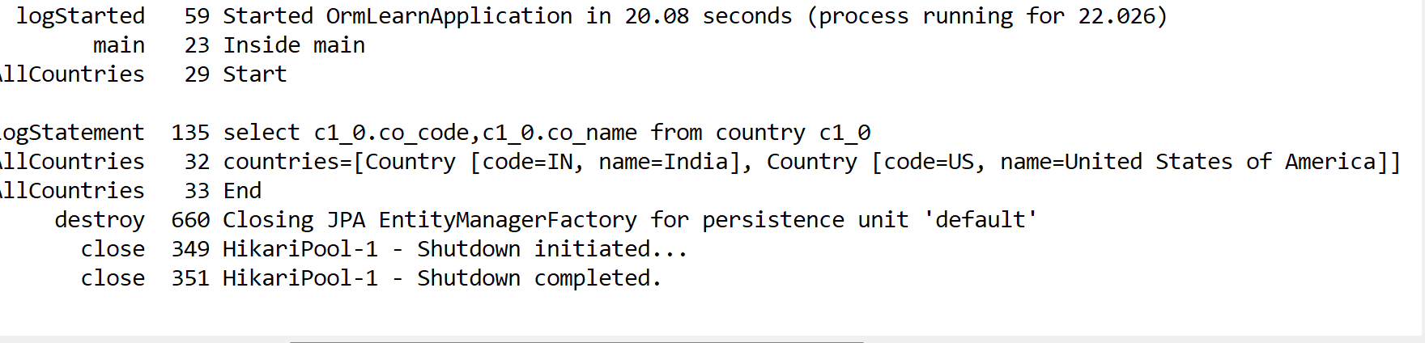

**EXERCISE 4**

**DIFFERENCE BETWEEN JPA, HIBERNATE AND SPRING DATA JPA**

**JPA (JAVA PERSISTENCE API)**

JPA is a Java specification for mapping Java objects to relational database tables.

Provides APIs for persisting, updating, retrieving, and deleting Java objects from databases.

JPA is not an implementation — it only defines *what* to do, not *how* to do it.

**HIBERNATE**

Hibernate is a popular ORM (Object Relational Mapping) tool and a concrete implementation of JPA.

It provides: Session management,Transaction handling,Caching,Lazy loading, etc.

Hibernate extends JPA with more features.

**SPRING DATA JPA**

Spring Data JPA is not animplementation of JPA, but a framework on top of JPA

It removes boilerplate code by using interfaces like JpaRepository.

Minimal code

**Hibernate: // Requires manual session, transaction, and error handling.**

   /* Method to CREATE an employee in the database */

   public Integer addEmployee(Employee employee){

      Session session = factory.openSession();

      Transaction tx = null;

      Integer employeeID = null;

      try {

         tx = session.beginTransaction();

         employeeID = (Integer) session.save(employee);

         tx.commit();

      } catch (HibernateException e) {

         if (tx != null) tx.rollback();

         e.printStackTrace();

      } finally {

         session.close();

      }

      return employeeID;

   }

**Spring Data JPA**  
EmployeeRespository.java

public interface EmployeeRepository extends JpaRepository<Employee, Integer> {

}

EmployeeService.java

@Autowire

  private EmployeeRepository employeeRepository;

@Transactional

public void addEmployee(Employee employee) {

  employeeRepository.save(employee);

  }

**Spring Data JPA: // Much cleaner — no session, no transaction management, just one line to save.**